**Unit 1**

Python History and Origin : <https://www.javatpoint.com/python-history>

Python Features: <https://www.geeksforgeeks.org/python-features/>

Python Advantages and Disadvantages: <https://techvidvan.com/tutorials/python-advantages-and-disadvantages/>

Python Applications: <https://www.javatpoint.com/python-applications>

Python Interactive Help Feature

<https://www.geeksforgeeks.org/help-function-in-python/>

Python Syntax error

<https://realpython.com/invalid-syntax-python/>

Types of errors

<https://en.wikibooks.org/wiki/Python_Programming/Errors>

**UNIT 2**

**Software development process:**

There is much more to programming than writing lines of code, just as there is more to building houses than pounding nails. The “more” consists of organization and planning, and various conventions for diagramming those plans. Computer scientists refer to the process of planning and organizing a program as software development. There are several approaches to software development. One version is known as the waterfall model. The waterfall model consists of several phases:

1. Customer request—In this phase, the programmers receive a broad statement of a problem that is potentially amenable to a computerized solution. This step is also called the user requirements phase.

2. Analysis—The programmers determine what the program will do. This is sometimes viewed as a process of clarifying the specifications for the problem.

3. Design—The programmers determine how the program will do its task.

4. Implementation—The programmers write the program. This step is also called the coding phase.

5. Integration—Large programs have many parts. In the integration phase, these parts are brought together into a smoothly functioning whole, usually not an easy task.

6. Maintenance—Programs usually have a long life; a life span of 5 to 15 years is common for software. During this time, requirements change, errors are detected, and minor or major modifications are made.

The phases of the waterfall model are shown in Figure . As you can see, the results of each phase flow down to the next. However, a mistake detected in one phase often requires the developer to back up and redo some of the work in the previous phase. Modifications made during maintenance also require backing up to earlier phases. Taken together, these phases are also called the software development life cycle. Although the diagram depicts distinct phases, this does not mean that developers must analyze and design a complete system before coding it. Modern software development is usually incremental and iterative. This means that analysis and design may produce a rough draft, skeletal version, or prototype of a system for coding, and then back up to earlier phases to fill in more details after some testing. For purposes of introducing this process, however, we treat these phases as distinct. Programs rarely work as hoped the first time they are run; hence, they should be subjected to extensive and careful testing. Many people think that testing is an activity that applies only to the implementation and integration phases; however, you should scrutinize the outputs of each phase carefully. Keep in mind that mistakes found early are much less expensive to correct than those found late.

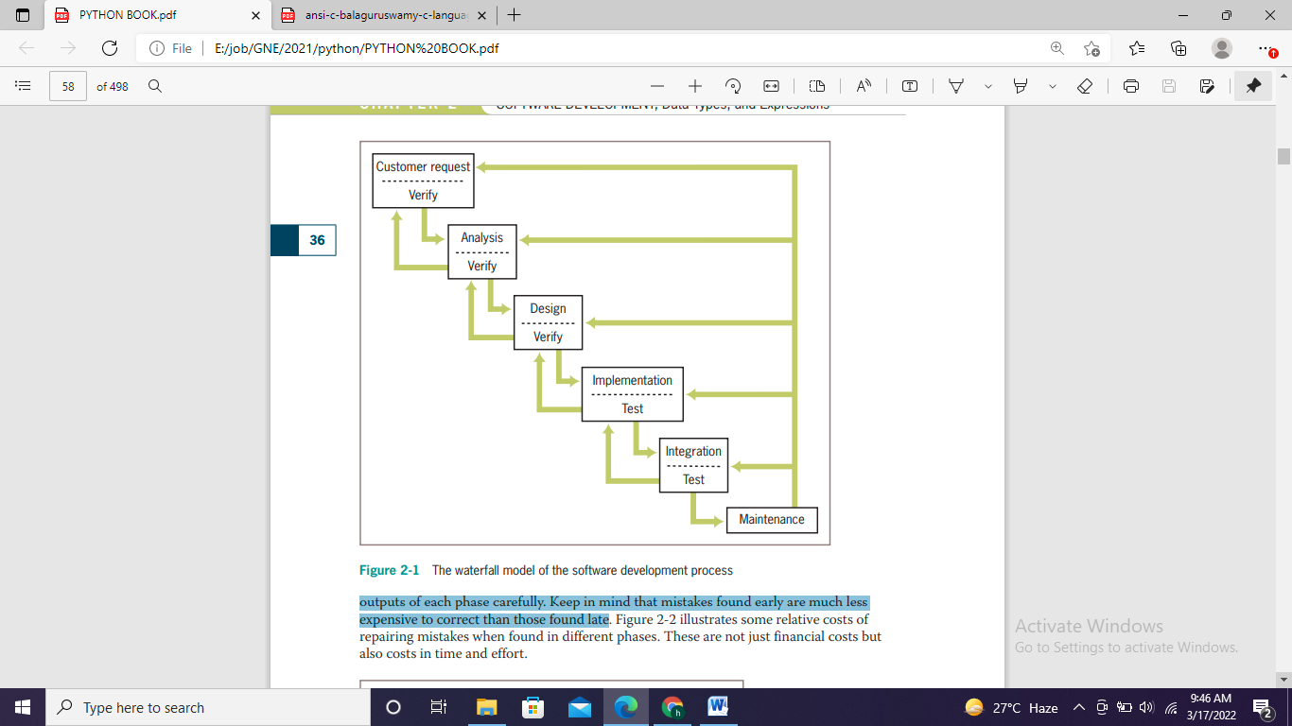

Python data types: <https://www.javatpoint.com/python-data-types>

Python operators: <https://www.geeksforgeeks.org/python-operators/>

Precedence and Associativity of Operators in Python: <https://www.geeksforgeeks.org/precedence-and-associativity-of-operators-in-python/>

Python functions: <https://www.geeksforgeeks.org/python-functions/>

**UNIT 3**

Python loops: <https://www.geeksforgeeks.org/loops-in-python/>

Python output formatting: <https://www.geeksforgeeks.org/python-output-formatting/>

Python if/else statement: <https://www.geeksforgeeks.org/python-if-else/>

**Unit 4**

Python string: <https://www.geeksforgeeks.org/python-strings/>

String functions:  <https://www.geeksforgeeks.org/python-string-methods/>

String encryption/ decryption: <https://www.geeksforgeeks.org/how-to-encrypt-and-decrypt-strings-in-python/>

Text files: <https://www.geeksforgeeks.org/reading-writing-text-files-python/>